Legal pitch touches a runner trying to score

The ball becomes dead and runners advance one base, or return to their bases, without liability to be put out, when … any legal pitch touches a runner trying to score; runners advance [OBR 5.06(c)(8)].
Rule 6.05(n), which will be examined in more detail later, describes the effects that arise when a runner attempting to steal home base, is hit by a pitched ball while passing through the strike zone. It should be noted that the legal pitch discussed in this rule touches the runner before entering the strike zone.
In this situation, the batter is credited with a ball, the run is scored and the touched runner is credited with a steal.
As far as the advances by other runners are concerned, we have to evaluate whether, at the time of the pitch, the offensive team were committed to stealing a base; if so, they should be credited with a steal; if not, their advances are noted in the box of the bases they were awarded with the symbol ‘WP’ or ‘PB’,
It is worth noting that when the ball in question is the fourth, the batter is awarded first base and all forced advances by runners are treated as if they had occurred on a base on balls, including a run scored with bases full.
Example 111: In the course of an attempted double steal, the lead runner is touched by the pitched ball before he reaches home base.
As he was clearly in the act of stealing a base, both advances are recorded with the abbreviation “SB”.
WBSC |  | Traduction dans l’outil de scorage |  | Outil
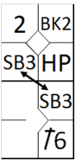 |  | /* Le premier batteur gagne la première base sur un 'hit by pitch' */  action { batter -> HP }  /* Le coureur en 1 avance sur un balk */  action { runner1 -> BK }  /* Le batteur suivant frappe un simple sur l'arrêt court, le coureur avance d'une base */  action { batter -> 1B6, runner2 -> + }  /* les deux coureurs volent une base */  action { runner1 -> SB , runner3 -> SB } |  | 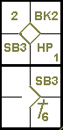

Example 112: With runners on first and third base, the lead runner is touched by the legally pitched ball before reaching home base.
The run is allowed, the leading runner is credited with a stolen base and the other runner’s advance to second base is recorded with the notation “WP” or “PB”, depending on the situation.
WBSC |  | Traduction dans l’outil de scorage |  | Outil
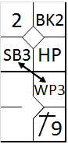 |  | /* Le premier batteur gagne la première base sur un 'hit by pitch' */  action { batter -> HP }  /* Le coureur en 1 avance sur un balk */  action { runner1 -> BK }  /* Le batteur suivant frappe un simple dans le champ centre, le coureur avance d'une base */  action { batter -> 1B6, runner2 -> + }  /* le premier coureur vole une base, tandis que le second profite d'un lancer fou */  action { runner1 -> WP , runner3 -> SB } |  | 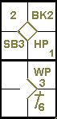

Example 113: With third and first bases occupied, and a full count to the batter, there is an attempted double steal.
The lead runner is touched by the ball before reaching the strike zone.
The run is allowed, the runner who scored is credited with a steal and the batter, as this was the fourth ball, is awarded first base. This latter event also justifies the second runner’s advance, regardless of whether he was already attempting to steal a base (forced advance).
WBSC |  | Traduction dans l’outil de scorage |  | Outil
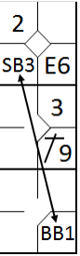 |  | /* Le premier batteur frappe une balle vers l'arrêt court qui commet une erreur */  action { batter -> E6 }  /* Le batteur suivant frappe un simple dans le champ droit, le coureur gagne deux bases */  action { batter -> 1B9 , runner1 -> ++ }  /* le batteur suivant obtient un 'base on ball' alors que le coureur était entrain de voler */  action { batter -> BB , runner1 -> + , runner3 -> SB } |  | 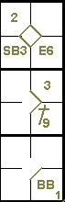

Example 114: With bases loaded, two out and a full count to the batter, the legally pitched ball slips from the pitcher’s hand and hits the runner leaving third base before entering the
strike zone.
Given that the pitch is also the fourth ball, all (forced) advances occur as a consequence of the base awarded to the fourth batter regardless of any attempts to steal a base.
WBSC |  | Traduction dans l’outil de scorage |  | Outil
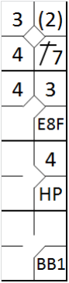 |  | /* Le premier batteur frappe un hit en champ gauche */  action { batter -> 1B7 }  /* Le batteur suivant frappe une fly dans le centre qui est mal rattrapée, le coureur avance sur l'erreur */  action { batter -> E8F , runner1 -> (2) }  /* Le coureur suivant gange une base sur un 'hit by pitch', les deux coureurs avancent */  action { batter -> HP , runner1 -> + , runner2 -> + }  /* Le batteur suivant gagne la première base un 'base on ball' */  action { batter -> BB , runner1 -> + , runner2 -> + , runner3 -> + } |  | 